Hammond and Ratcliff Gardens Working Group Meeting
25/9/23
Attendees: Jason Papworth, Pam Maskell, Rachel Thackray, Colin Day, Claire Brooks

Les Page has agreed to join the maintenance committee focusing on Ratcliff. Rachel will be in touch with him.
The signs have been made up based on artwork from the school children.

Two sets of actions were identified. Those critical to supporting the community morning on 1st October and those that can be delayed a little.

Must be done for 1st October (all for Hammond, Ratcliff might have to be delayed)
- Buy and have delivered compost – Rachel
- Buy and have delivered plants/shrubs etc – Jason
- Bring bird boxes, bat boxes, pallets for bug hotel – Jason
- Have refreshments available – Pam
- Tell networks about the community morning (details in blue below) – all

Can be delayed:
- Put up signs – Rachel and Jason
- Get more soil for Hammond – Rachel and Jason
- Get soil in planters for Ratcliff – Rachel and Jason
- Get compost in planters for Ratcliff – Rachel and Jason
- Ratcliff area cleared of waste – Aubrey and local residents
- Buy and have delivered plants/shrubs etc – Jason
- Arrange for overhanging trees at Hammon to be cut back – Rachel and Jason
- Build demo table – Jason or James?
- Build benches around planters – James

Signs:
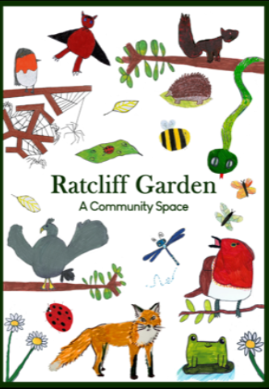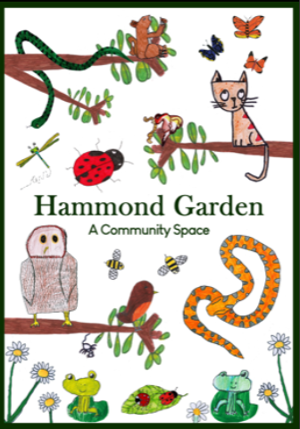

Details about 1st October to be shared with networks:
A WORKING GROUP HAS FORMED TO TRANSFORM TWO CURRENTLY UNDERUSED AREAS OF PILGRIM CLOSE (HAMMOND GARDEN – What3words - assure.essay.speeding) AND (RATCLIFF GARDEN – what3words - because.spellings.feared).

HAMMOND GARDEN:
We plan to add plants, shrubs, flowers, planters, picnic bench and other seating, a bug hotel, bird boxes etc to encourage wildlife, biodiversity and a love of our natural environment . We hope that the space will be interactive and will encourage community togetherness across all ages. People might come to harvest fruit and vegetables, explore the wildlife, enjoy a picnic of simply sit and chat.

RATCLIFF GARDEN:
We are planning a more simple use of this space. The primary purpose will be to attract wildlife. There will still be planters but the plants grown will those designed to encourage wildlife rather than for the purpose of harvesting. A bench/picnic table will be available to sit and enjoy this space.

On the 1st October, starting at 9am a community volunteer morning is being held in Hammond Garden, Pilgrim Close, to try and bring the plan for Hammond Garden to fruition, work on Ratcliff will come a little later.
Volunteers are needed to:
- Plant seeds, plants, flowers, shrubs etc (guidance given)
- Put up wildlife boxes
- Move compost to planters
There will be a talk on plants (Jason Papworth – Horticulturalist) and one on wildlife (Colin Day – Local Naturalist)
Families welcome. We suggest year 1 – 5 children attend at 10am and year 6 plus at 11am. If you have a mixture in your family it’s fine to attend either. The children will be shown how to correctly plant flowers.
If you have garden gloves, trowels etc, please bring them

